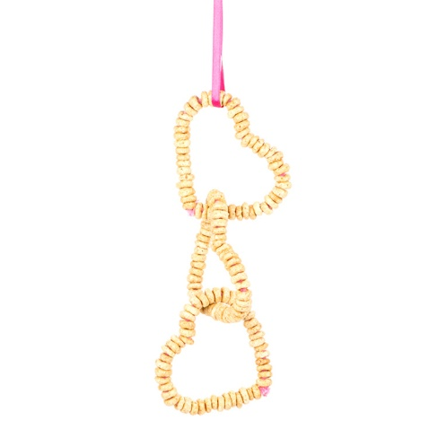
‘Get Nifty with Nature’
Fun family craft sessions with
Me_{2Activities}

Help your child to learn new skills and enjoy a fun packed session creating some wonderful nature based crafts.
Design a ‘grass head’, paint a pot and make a bird feeder
_{for just £4.00 per child!}
_{Suitable for ages 0-12 years}

_{Date} | _{Venue} | _{Time}
_{Tuesday}  _{21st February} | _{The Penny Hedge,}  ^{Botany Way,}  ^{Whitby}  ^{(near Sainsburys)} | _{10.30am-12.30pm}

Book now to save your place by calling in or
_{call 07522 172622}

