http://oswego.org/ocsd-web/games/mathmagician/mathsmulti.html
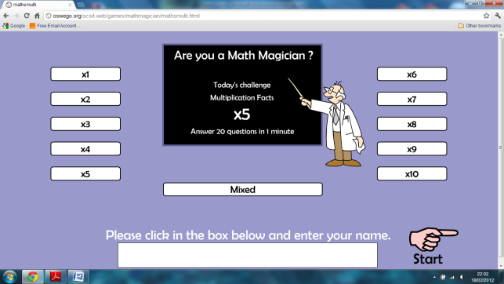
http://www.multiplication.com/games
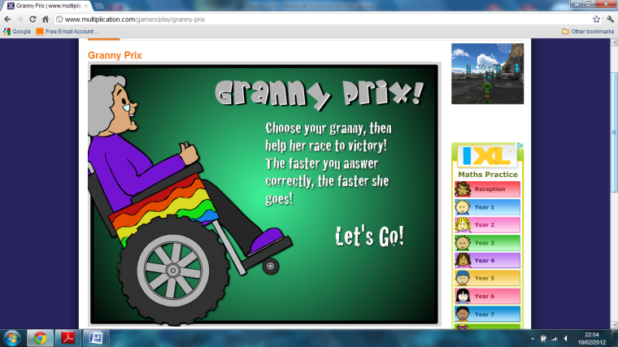
http://www.crickweb.co.uk/ks2numeracy-multiplication.html
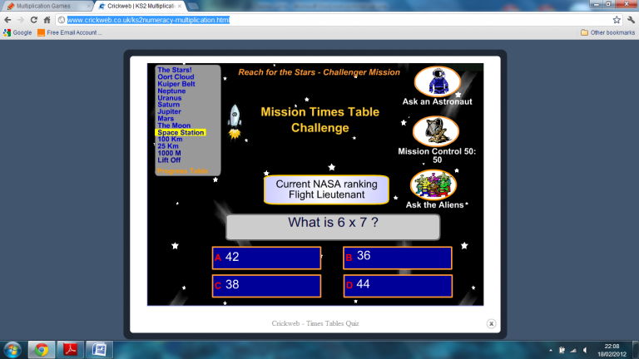
http://www.mad4maths.com/multiplication_table_math_games/
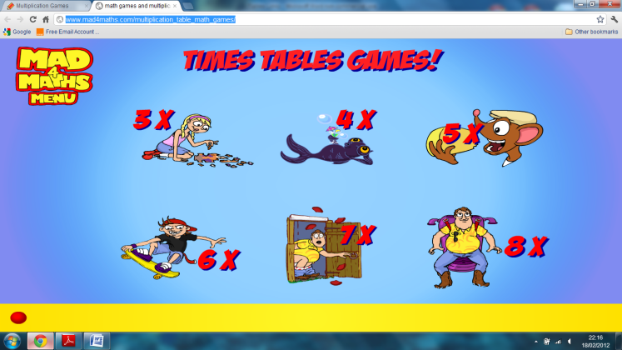

http://www.ictgames.com/multiBounce/index.html
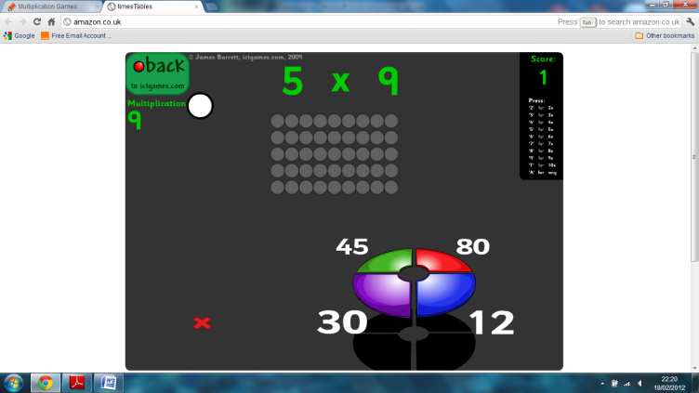
http://www.what2learn.com/home/examgames/maths/subtraction/
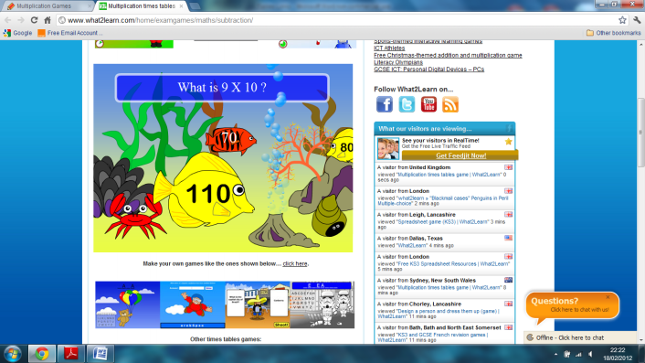
http://www.learnyourtables.co.uk/en/index2.htm
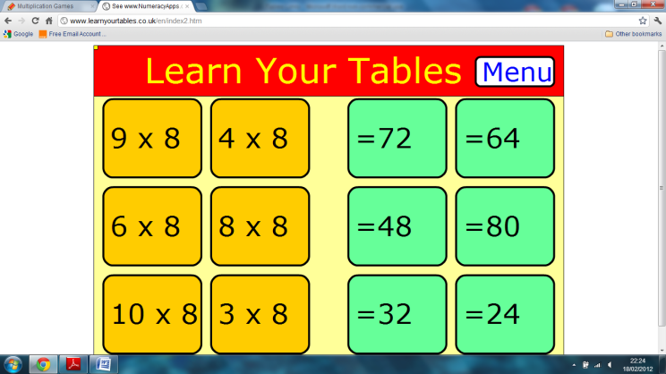
http://www.wmnet.org.uk/resources/gordon/Hit%20the%20button%20v9.swf
(Copy and paste this link into your browser)
